Tolerance Range
Graphing Activity

Rainbow trout have seen a population decline in the Western United States over the last several decades. There are a wide variety of conditions that are threatening the population, including pollution, climate change, and invasive species. This activity will look at the effects of varying two specific abiotic factors on a controlled population of trout.

Graph the Water Temperature tolerance data below for Rainbow trout. Water temperature is an independent variables and should be graphed on the X-axis. The number of fish, a dependent variable, should be graphed on the Y-axis.

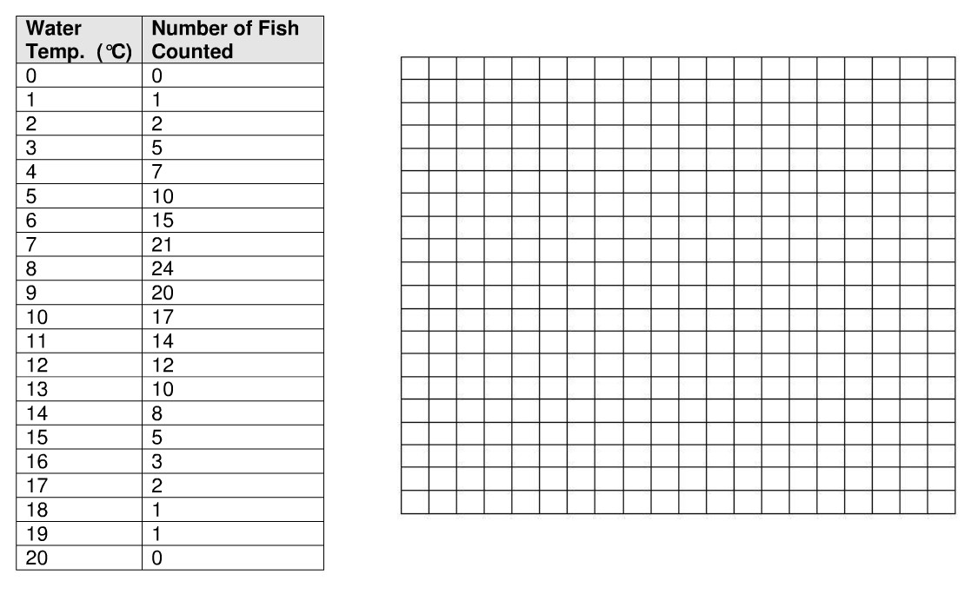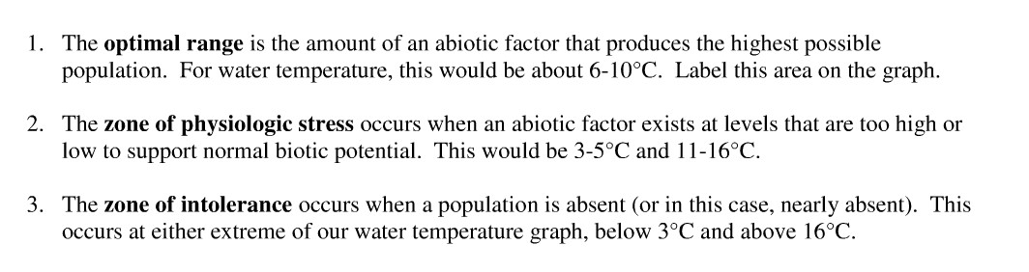
Graph the Dissolved Oxygen tolerance data below for Rainbow trout. Dissolved Oxygen is an independent variables and should be graphed on the X-axis. The number of fish, a dependent variable, should be graphed on the Y-axis.
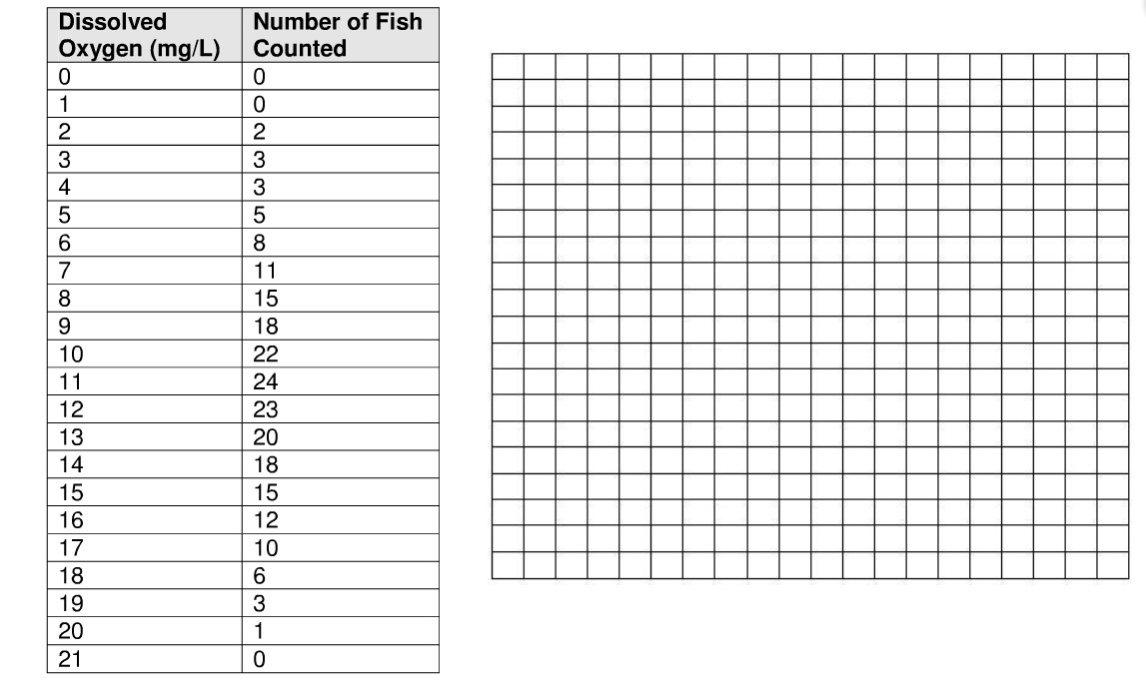

Conclusions

- Label the optimal range, zones of stress, and zones of intolerance on the graph above.

- A Biological indicator species are those whose population can signal the overall healthy balance of an ecosystem. Why would the Rainbow trout be an effective indicator species?

